Students

Your Future. Your Way.
Whether you're exploring different career ideas, choosing your GCSEs, A Levels or Post-16 options, applying for university, considering an apprenticeship, or thinking about work experience, this section is here to help. You'll find information, advice, and resources to support you in making informed decisions about your next steps and future career pathway.
Take time to explore the opportunities available, develop your skills, and discover where your interests and talents could take you. Your career journey is unique, and we're here to support you every step of the way.

What is it?
NEW What are T Levels
What are V Levels?
What is an apprenticeship?
Finding the Best Apprenticeship for You
NEW Foundation Apprenticeships
NEW Apprenticeship Levels Explained
NEW Foundation Apprenticeships
NEW What is a degree apprenticeship?

All Years
BBC Bitesize: Careers - BBC Bitesize
Unifrog: https://www.unifrog.org/
icould: icould - Career ideas and information for your future
Labour Market Information (LMI): Explore LMI data – LMI For All
(Careerometer – LMI For All): Careerometer

Choices after GCSEs (Post-16)
National Careers Service: Post 16 options | Get careers information and advice
Prospects: Post-16 options: a guide to your choices after GCSEs | Prospects.ac.uk
Dept for Education: Your training options | Skills for Careers
Search apprenticeship – Find an apprenticeship – GOV.UK

Choices after A Levels (Post-18)
University: The pros and cons of university | UCAS
Gap Year: Gap year | Prospects.ac.uk
Search apprenticeship – Find an apprenticeship – GOV.UK

Work Experience
Please add in PPT attached here
Career Guidance for Students | Explore Your Future Path | Futures For All
Virtual:
Springpod Virtual Work Experience Search | Springpod
InvestIN | The Ultimate Work Experience – InvestIN Education

Careers Guidance
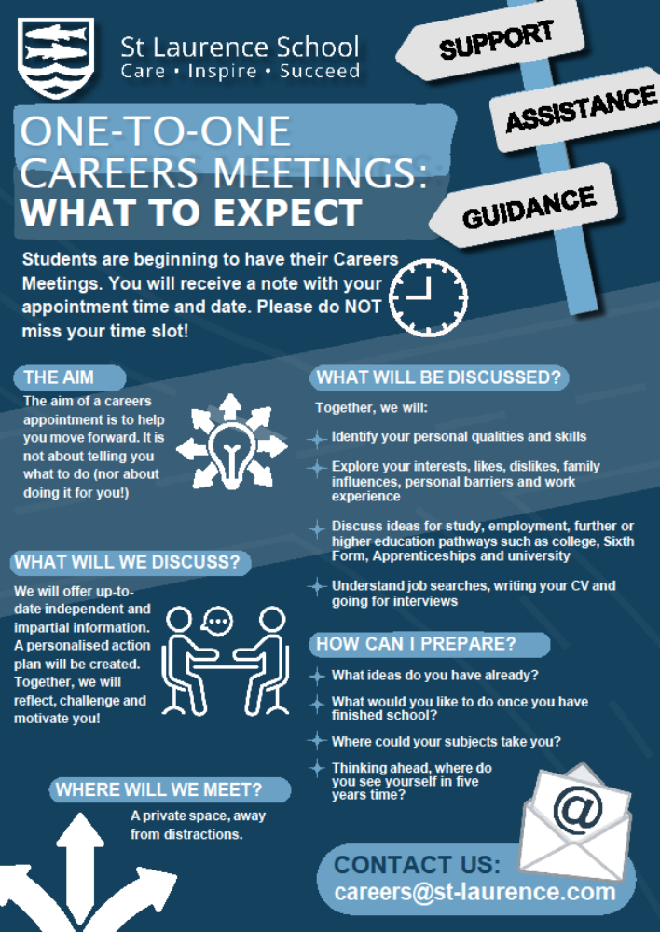
Destinations
