Absence Request Form






St Laurence School

Churchfields,

The Village School

Fitzmaurice Primary
School

Winsley Primary School

Westwood with Iford
Primary School

Christ Church CE VC
Primary School

This form should be handed in to school office at least 7 days prior to absence.
Taking your child out of school during term time may harm their academic progress
Schools are only permitted to authorise absence in exceptional circumstances, such as a:
- family emergency
- funeral of a close family member (please state relationship to you)
- wedding of a close family member (please state relationship to you)
From August 2024, schools are not permitted to authorise holidays in term time.
Absences adjacent to either side of a school holiday will no longer be routinely authorised.
Circumstances which are notified to the school after a decision has been made by the Head will not be considered. Therefore please be certain to provide all details of the exceptional circumstances relating to your application below and attach any supporting evidence.

PLEASE COMPLETE ONE FORM PER STUDENT
Pupil’s name:
Pupil’s school: |  |  |  |  |  |  | Year |  |  |  | Class/Form
Application date:
Name of parent(s) making application  (in block capitals) |  |  |  | Title | Forename |  |  |  | Surname
Full address of applicant:

Post code:
Names of sibling(s) also requesting the same absence |  |  |  |  |  | Name of school (if not same school)
Date of first day of absence |  |  |  |  |  | Date of last day of absence
Date of return to school |  |  |  |  |  | Total number of days requested
The exceptional circumstances for absence requested during term time are:

Parent/Carer signature |  |  |  |  |  |  |  | Date

Please see response overleaf

Dear Parent/Carer,
Your request for exceptional leave of absence has been considered in line with the 2024 Department for Education Statutory Guidance on School Attendance.

% Attendance to date
% Unauthorised absence to date

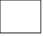
Leave of absence authorised
Please ensure that your child returns to school promptly following your leave of absence as failure to do so can result in their removal from the school roll.

Leave of absence unauthorised
Any absence from school during this time will be marked as unauthorised and may be referred to the Education Welfare Service and a Penalty Notice may be issued.

Signed (Headteacher/Head of School): ____________________________________________________________

Date: _________________________________

PUPIL LEAVE OF ABSENCE IN TERM TIME
Important notice to all parents and carers
If a student accumulates ten or more sessions (five days) of unauthorised leave of absence within the previous six-month period of the current academic year, the school must notify the Local Authority, and a Penalty Notice will be issued to each parent for each child where that applies.
From August 2024, the fine for school absences across the country will be £80 if paid within 21 days or £160 if paid within 28 days. This rate is in line with inflation and is the first increase since 2012.
In the case od repeated fines, if a parent receives a second fine for the same child within a three-year period, this will be charged at the higher rate of £160.
Fines per parent will be capped to two fines within any three-year period. Once this limit has been reached, other action like a parenting order or prosecution will be considered.
If you’re prosecuted and attend court because your child hasn’t been attending school, you could get a fine of up to £2,500.

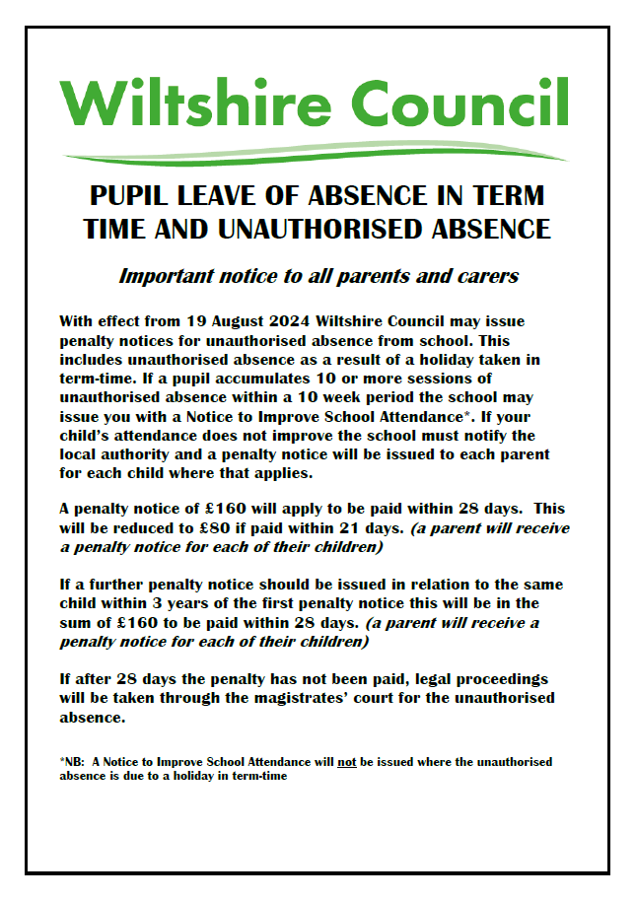

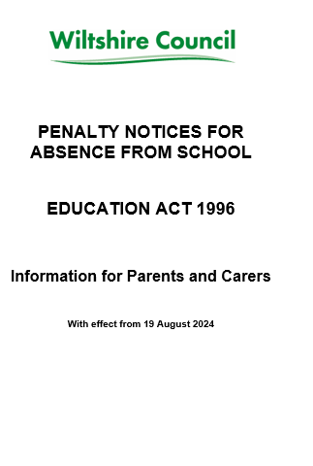
Unauthorised absence is where the school has not given permission for the absence or where no justifiable reason has been given to the headteacher or when a child does not register either in the morning or the afternoon before the school register is closed.
Why have I received this leaflet?
Either – you have received a Notice to Improve School Attendance warning of the possibility of a penalty notice being issued as your child has had at least 10 sessions of unauthorised absence within a 10 week period.
Or – your child has unauthorised absence which has not been agreed by the school but support is not deemed appropriate (eg for a family holiday). You will not have received a Notice to Improve School Attendance in this situation.
What can I do now?
- If you have been issued with a Notice to Improve School Attendance due to unauthorised absence, you should make sure that your child does not have any more unauthorised absence from school.
- You should make contact with the school and arrange to discuss the support available to help improve your child’s attendance

Can I get help if my child is not attending school regularly?
Yes, talk to your child’s school.

The Education Welfare Service may also help:
Please email: EWS@wiltshire.gov.uk

